SECTION 1

Assignment on Dichotomous keys

The first part of the assignment is to use your knowledge of Dichotomous keys to produce one on farm animals.

Your key MUST be completed on an A4 piece of paper and MUST include pictures or drawings of each animal. At each step you MUST write the characteristic which separates the animals.

The animals you must include on your key are:

Chook Cow Sheep
Dog Snake Cat
Emu Rabbit Kangaroo
Horse Mouse Duck

Please add 4 more animals of YOUR choice to the above list and then complete your key.

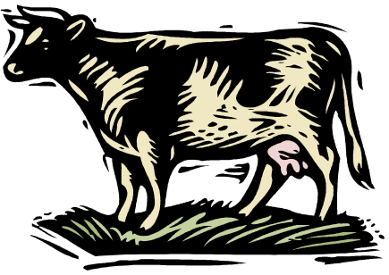
SECTION 2

Research Project on an Animal

The second part of the assignment is to select an animal of interest that you wish to research. Your assignment will be presented as a PPT or iMovie which includes the following information about your chosen animal:

1. A picture of the animal
2. Which sub group it belongs to
3. The characteristics that make
it part of its subgroup
4. Where it lives
5. What it eats
6. Its reproduction patterns
and growth of its young
7. Its lifecycle
8. A description of the animal
(eg: fur colour, size, shape, if it has scales or skin etc).
- Other interesting
information about your animal

Your iMovie or PPT will be marked on the detail you include, the presentation and the effort you place into its completion.

BOTH parts of the assignment are due in the final week of school.

